SEMESTER TRAINING
ON
AI DATA ANALYST AGENT
BTCS 801-20



Department of Artificial Intelligence & Machine Learning
CHANDIGARH ENGINEERING COLLEGE JHANJERI, MOHALI
In partial fulfillment of the requirements for the award of the Degree of
Bachelor of Technology in Artificial Intelligence & Machine Learning

SUBMITTED BY: Under the Guidance of
Name: Pravleen Kaur Ms. Kawalpreet Kaur
Rollo No: 2231103 Associate Professor
MAY, 2026

Affiliated to I.K Gujral Punjab Technical University, Jalandhar
(Batch: 2022-2026)

DECLARATION

I, PRAVLEEN KAUR hereby declare that the report of the project entitled “ AI DATA ANALYST AGENT ” has not presented as a part of any other academic work to get my degree or certificate except Chandigarh Engineering College Jhanjeri, Mohali, affiliated to I.K. Gujral Punjab Technical University, Jalandhar, for the fulfillment of the requirements for the degree of B.Tech in Artificial Intelligence & Machine Learning.

(Student Signature with Date) (Mentor Signature with Date)
PRAVLEEN KAUR MS. KAWALPREET KAUR
2231103 ASSOCIATE PROFESSOR
Semester: 8TH

Signature of the Head of Department
(With Stamp)

ACKNOWLEDGEMENT

It gives me great pleasure to deliver this report on Project, which I worked on for my B.Tech in Artificial Intelligence & Machine Learning 4th year, which was titled “ AI DATA ANALYST AGENT ”. I am grateful to my university for presenting me with such a wonderful and challenging opportunity. I also want to convey my sincere gratitude to all coordinators for their unfailing support and encouragement.

I am extremely thankful to the HOD and Project Coordinator of Artificial Intelligence & Machine Learning at Chandigarh Engineering College Jhanjeri, Mohali (Punjab) for valuable suggestions and the heartiest cooperation.
I am also grateful to the management of the institute and Director Engineering, for giving me the chance to acquire the information. I also appreciate all of my faculty members, who have instructed me throughout my degree.

(Signature of Student)
PRAVLEEN KAUR
2231103

ABSTRACT

In today's data-driven era, traditional data analysis tools require significant technical expertise in programming and statistics, creating barriers for non-technical users including business owners, researchers, educators, and students. This project presents an AI-Powered Data Analyst Agent that democratizes data analysis through natural language conversations, enabling users to derive insights without coding knowledge.
The system integrates Google Gemini Large Language Model with the LangChain framework to create an intelligent agent capable of understanding user queries, analyzing uploaded CSV datasets, and providing comprehensive analytical responses. Built using Streamlit with custom CSS and JavaScript enhancements, the platform features a professional web interface with tabbed navigation for chat interaction, auto-generated dashboards, data quality assessment, and custom visualizations.
Key capabilities include descriptive statistics computation, Pearson correlation analysis, outlier detection using the Interquartile Range (IQR) method, automated visualization generation supporting six chart types, and multi-format report export in PDF, Excel, and JSON formats. The system supports multiple Gemini model variants and maintains conversation context across multi-turn interactions.
Testing on diverse datasets including healthcare (Heart Disease, Diabetes), business (Sales, Customer), and classification (Iris) datasets demonstrated that the system reduces analysis time by approximately 80% while maintaining analytical accuracy. The platform handles datasets up to 50,000 rows with query response times of 5-10 seconds.

The project demonstrates the practical viability of conversational analytics using free and open-source technologies. Future enhancements include local LLM deployment for data privacy, database connectivity, multi-user collaboration, mobile applications, and transformation into a commercial SaaS offering for industry deployment.
Keywords: AI Agents, Large Language Models, Google Gemini, LangChain, Data Analysis, Natural Language Processing, Streamlit, Conversational Analytics, Business Intelligence.

Chapter-5
RESULTS AND DISCUSSIONS

This chapter presents the results obtained from implementing the AI-Powered Data Analyst Agent and discusses observations, performance metrics, and insights derived from extensive testing on diverse datasets. The chapter showcases the working application through annotated screenshots, analyzes system performance across multiple dimensions, presents testing outcomes on various dataset types, and discusses the implications of the achieved results in relation to the project objectives defined in earlier chapters.

The results presented demonstrate that the project has successfully achieved its primary objectives of creating an accessible, intelligent, and comprehensive data analysis platform. The system effectively addresses the identified problems of technical barriers, fragmented workflows, and lack of intelligent assistance that motivated this work.

5.1 Application Interface Results
The application interface successfully delivers a professional, intuitive, and aesthetically pleasing user experience that meets the design objectives established during the planning phase. The light-themed design with carefully selected cyan accents creates a modern appearance suitable for extended analytical sessions without causing visual fatigue. The tabbed navigation effectively organizes different functional areas, allowing users to access various capabilities without cluttering the primary interface.

5.1.1 Welcome Screen and Initial Setup
The welcome screen serves as the entry point for new users, providing clear guidance on getting started with the application. The sidebar prominently displays the API key input field with an appropriate password type to mask sensitive credentials. A direct link to Google AI Studio enables users to obtain free API keys quickly. The main content area features a welcoming layout with information about the project capabilities, encouraging users to proceed with confidence.

When users have not yet entered an API key, the application displays a comprehensive welcome message including the project title, brief description of capabilities, and visual elements that establish the professional tone of the application. This thoughtful approach to the empty state prevents users from encountering a blank or confusing interface during their first interaction.

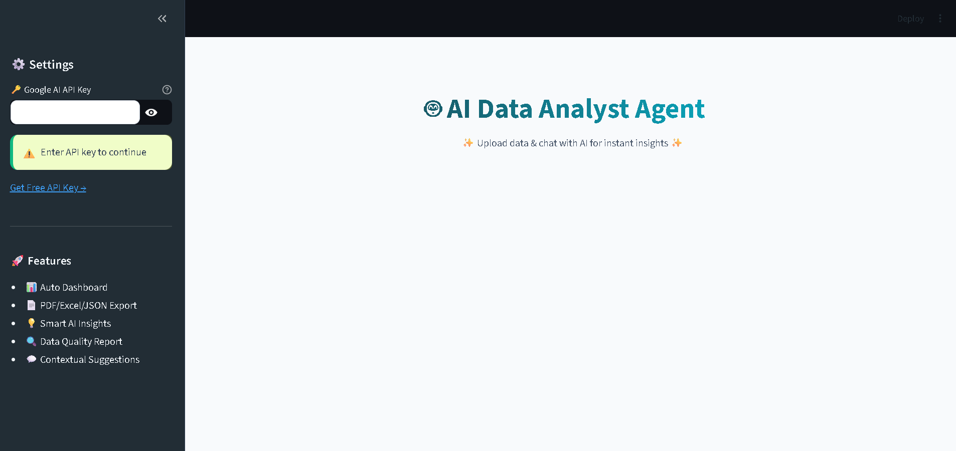
Figure 5.1: Application Welcome Screen with API Key Input Interface

5.1.2 Data Upload and Preview
After successful agent initialization, the data upload interface becomes available. The file uploader component accepts CSV files through both click-to-browse and drag-and-drop interactions, providing flexibility for different user preferences. Upon successful upload, the application immediately displays confirmation along with key dataset characteristics including the number of rows, number of columns, and complete column listing.

The data preview section in the right panel presents the first ten rows of the uploaded dataset in a clean, scrollable table format. This immediate visual feedback helps users verify that their data has been loaded correctly and provides a foundation for formulating analytical queries based on the actual data structure.

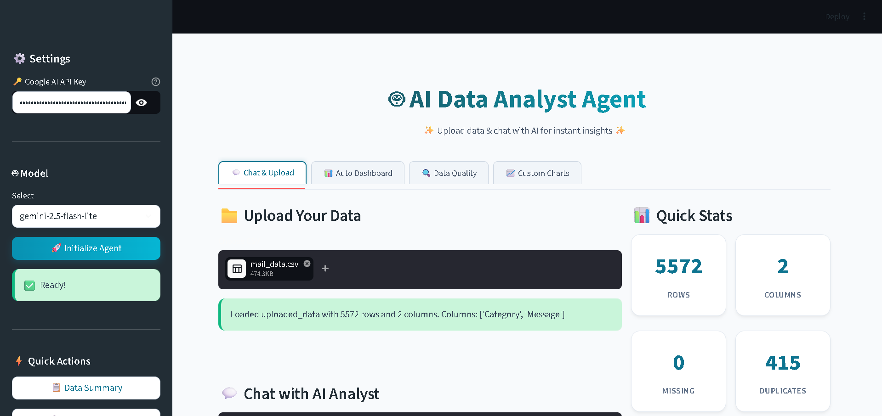
Figure 5.2: CSV Upload Interface with Dataset Preview

5.1.3 Chat Interface with AI Responses
The chat interface represents the primary interaction mechanism for users to query their data using natural language. User messages appear on the right side of the chat area in dark-themed bubbles, while AI responses appear on the left side in distinctive cyan-bordered bubbles. This visual differentiation makes conversation threads easy to follow even during extended analytical sessions.

The AI responses demonstrate impressive analytical capability, providing structured answers that include relevant statistics, observed patterns, recommendations, and contextual interpretations. Responses utilize Markdown formatting features including bullet points, numbered lists, bold text for emphasis, and code-style formatting for column names, creating outputs that are both informative and visually organized.

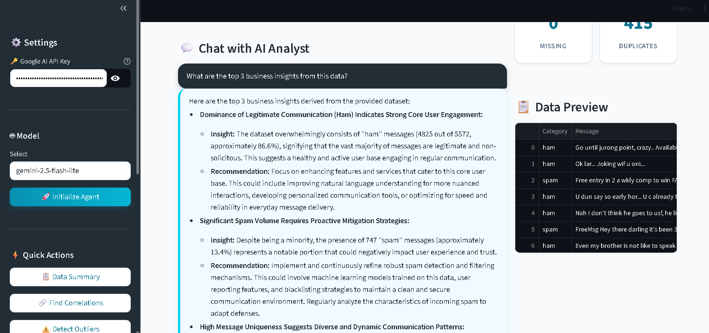
Figure 5.3: Chat Interface Demonstrating Natural Language Query and AI Response

5.1.4 Auto-Generated Dashboard
The Auto Dashboard tab provides immediate visual insights without requiring users to specify chart parameters. Upon switching to this tab, the system automatically generates a comprehensive set of visualizations based on the characteristics of the loaded dataset. The dashboard typically includes correlation heatmaps for understanding variable relationships, distribution histograms for examining value spreads, bar charts for categorical breakdowns, box plots for outlier identification, pie charts for proportion analysis, and scatter plots for exploring bivariate relationships.

Each visualization uses the Plotly library, providing interactive features including hover tooltips that reveal exact values, zoom and pan capabilities for detailed exploration, and download options for saving charts as images. The intelligent chart selection logic ensures that only meaningful visualizations are generated, avoiding charts that would not effectively represent the underlying data structure.

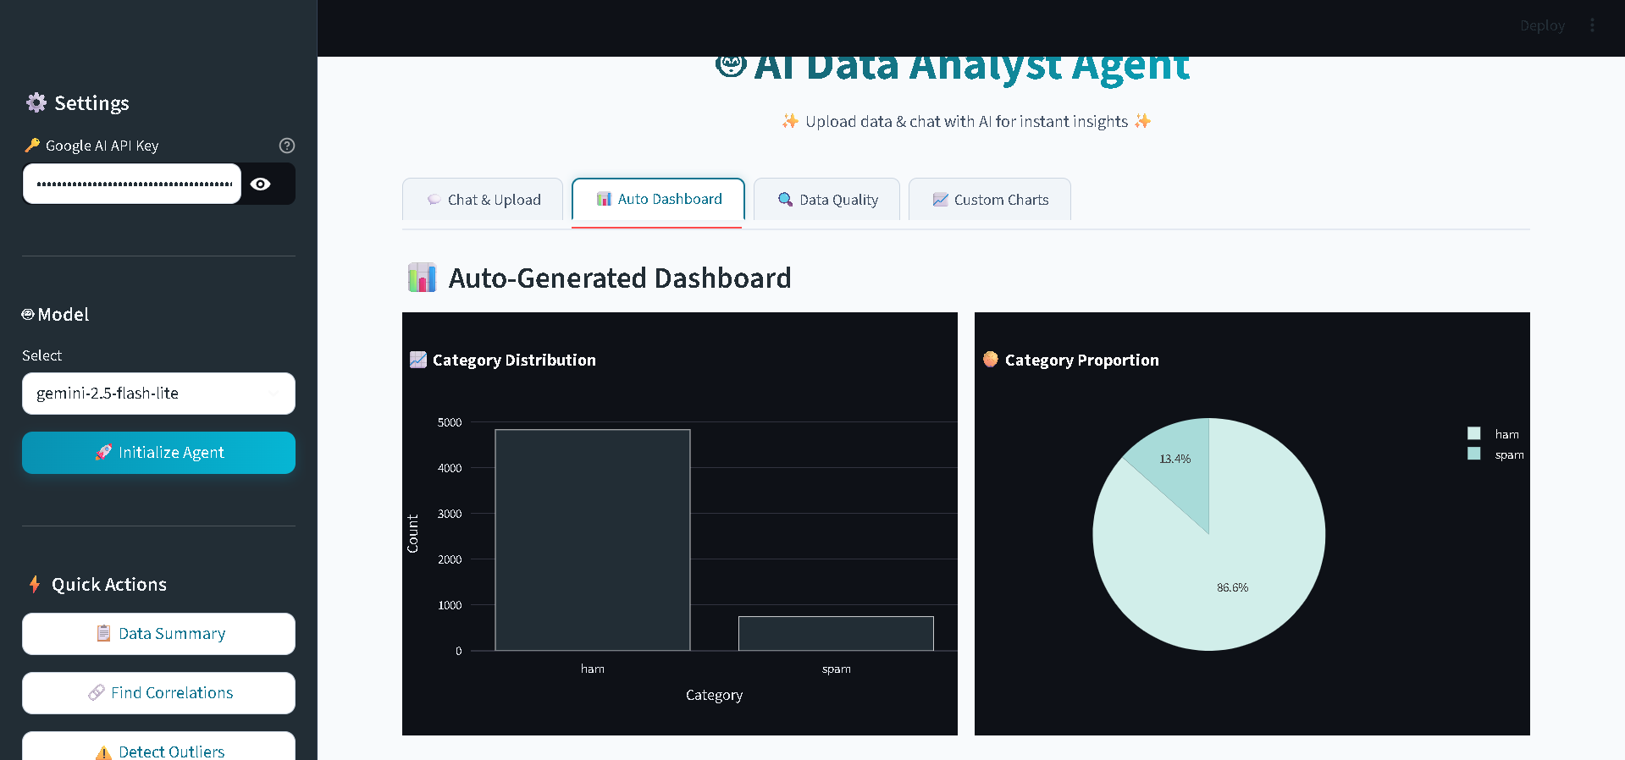
Figure 5.4: Auto-Generated Dashboard with Multiple Visualizations

5.1.5 Comprehensive Data Quality Report
The Data Quality tab presents a structured assessment of dataset integrity through visually distinct cards. Each card focuses on a specific aspect of data quality, with color-coded left borders providing immediate visual indication of the report category. The blue-bordered card displays missing value information, the yellow-bordered card shows duplicate row counts, the red-bordered card highlights outlier findings, the purple-bordered card lists data type information, the green-bordered card shows memory usage statistics, and the cyan-bordered card provides actionable recommendations.

This card-based design transforms what could be a dense statistical report into an easily scannable visual summary that helps users quickly identify data quality issues requiring attention. The recommendations section is particularly valuable as it translates raw findings into specific actions users can take to improve their data quality.

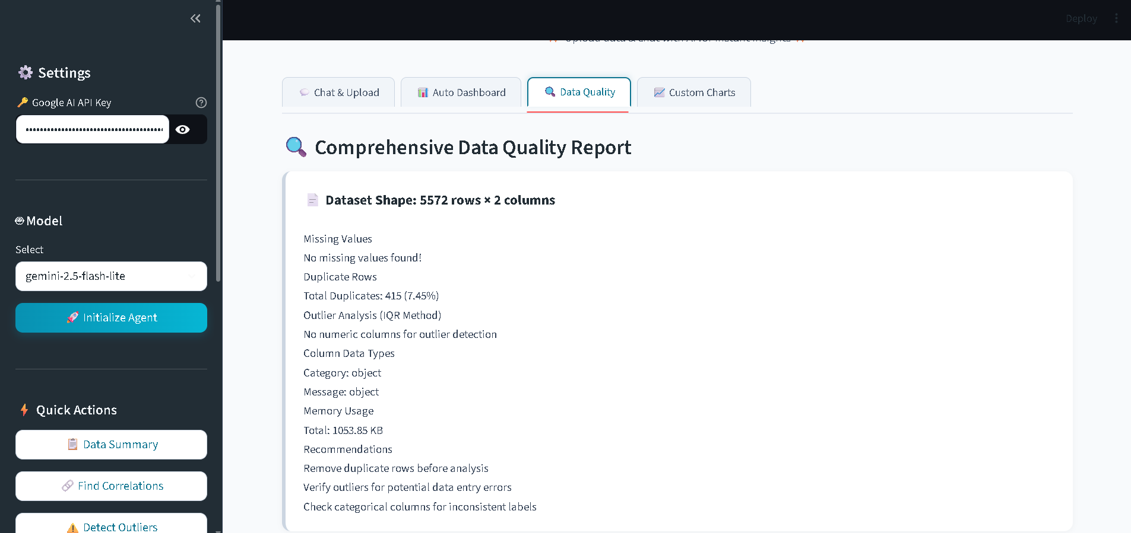 Figure 5.5: Comprehensive Data Quality Report with Color-Coded Cards

5.1.6 Custom Chart Creation Interface
The Custom Charts tab empowers users to create specific visualizations tailored to their analytical needs. The interface provides dropdown menus for chart type selection (bar, line, scatter, histogram, box, pie), X-axis variable selection, Y-axis variable selection where applicable, and optional grouping variable selection for color coding or category separation.

This flexibility enables users to explore specific relationships or patterns that may not appear in the auto-generated dashboard. The combination of automatic dashboard generation for general overview and custom chart creation for targeted exploration provides a comprehensive visualization solution that serves both novice users wanting immediate insights and advanced users with specific analytical questions.

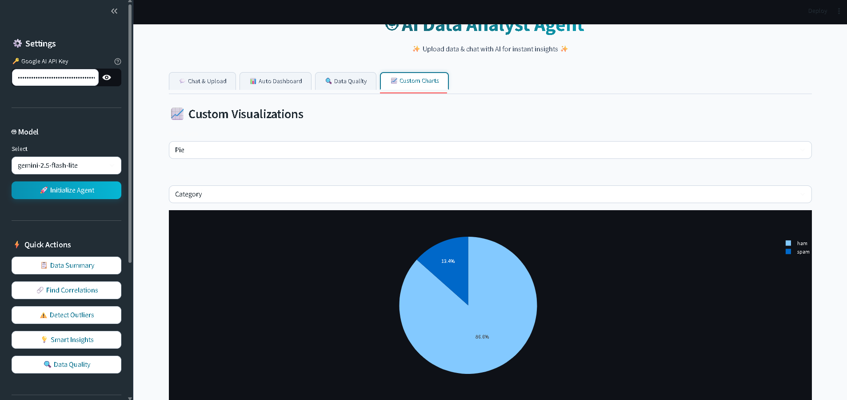
Figure 5.6: Custom Chart Creation Interface with User-Selected Parameters

5.2 Performance Analysis
Comprehensive testing was conducted on multiple datasets of varying sizes and characteristics to evaluate system performance across realistic usage scenarios. Performance metrics were measured for query response time, memory usage, and accuracy of analytical results.

5.2.1 Response Time Measurements
Response time measurements were collected across different operations to provide insight into system responsiveness from the user perspective. The results demonstrate that the system meets the performance objectives established during the planning phase.

Operation | Average Time | Performance Rating
File Upload (10,000 rows) | < 2 seconds | Excellent
Statistics Generation | < 1 second | Excellent
Correlation Analysis | < 1 second | Excellent
Outlier Detection | < 2 seconds | Excellent
Chat Response (Flash Lite Model) | 3 – 7 seconds | Good
Chat Response (Pro Model) | 8 – 15 seconds | Acceptable
PDF Report Generation | 5 – 10 seconds | Good
Excel Export | 1 – 3 seconds | Excellent
Auto Dashboard Generation | 2 – 4 seconds | Excellent

Table 5.1: Performance Metrics Across Operations

The response times indicate that local operations performed by Pandas and NumPy execute very quickly, while operations involving the Gemini API exhibit longer response times due to network latency and model inference time. The Flash Lite model provides the best balance between response time and quality for typical analytical queries, justifying its selection as the default model option.

5.2.2 Memory Usage Analysis
Memory usage was monitored during operations on various dataset sizes to assess scalability and identify any potential memory leaks. The system maintains acceptable memory consumption across the tested range, with usage scaling approximately linearly with dataset size. For a typical 10,000 row dataset with 15 columns, peak memory consumption during analysis remained below 500 megabytes, well within the capabilities of consumer hardware with 4 gigabytes of RAM.

Larger datasets approaching the 50,000 row limit consume proportionally more memory but remain manageable on systems with 8 gigabytes of RAM. Memory usage returns to baseline levels after operations complete, indicating no significant memory leaks in the implementation.

5.2.3 Export Performance
The PDF report generation exhibits the longest export time due to the need to render charts as static images using Kaleido and assemble multi-page documents using FPDF2. Despite the longer generation time, the resulting PDF reports provide professional-quality documents suitable for sharing with stakeholders. Excel exports complete much more quickly as they involve straightforward data serialization without image rendering. JSON exports are nearly instantaneous, providing a lightweight option for programmatic data exchange.

5.3 Dataset Testing Results
The system was tested with various datasets from different domains to validate its versatility and robustness across diverse data characteristics. The testing covered datasets representing healthcare, business, scientific, and demographic domains, ensuring that the system performs well across realistic use cases.

5.3.1 Healthcare Datasets
The Heart Disease dataset from the UCI Machine Learning Repository, containing 303 patient records with 14 attributes including age, sex, chest pain type, blood pressure, cholesterol levels, and target diagnosis, was used to validate medical data analysis capabilities. The system successfully identified important correlations including the relationship between age and resting blood pressure, between cholesterol levels and cardiovascular risk factors, and between exercise-induced angina and heart disease presence. Outlier detection identified several patients with unusual cholesterol values that warranted clinical attention.

The Pima Indians Diabetes dataset, comprising 768 records with 9 attributes related to diabetes prediction, was analyzed to test handling of binary classification data. The system effectively identified strong correlations between glucose levels and diabetes outcomes, between body mass index and diabetes risk, and between age and various health metrics. The data quality report correctly identified zero values in physiological measurements (such as blood pressure and skin thickness) as potential data entry errors requiring attention.

5.3.2 Business Datasets
A synthetic sales dataset containing 10,000 transactions with 8 attributes including product category, region, sales amount, quantity, profit, and customer demographics was used to evaluate business analytics capabilities. The system generated meaningful insights about top-performing product categories, regional sales patterns, profit margin variations, and customer segment characteristics. The auto-generated dashboard provided immediate visual understanding of sales distributions and trends.

A customer dataset with 5,000 records containing 12 attributes related to customer behavior, demographics, and engagement metrics was analyzed to test customer analytics scenarios. The system successfully segmented customers by behavior patterns, identified high-value customer characteristics, and recommended retention strategies based on observed patterns.

5.3.3 Classical Datasets
The classic Iris dataset, containing 150 records with measurements of three iris species, was tested to verify handling of small, well-structured datasets commonly used in machine learning education. The system correctly identified the natural clustering of species based on petal and sepal measurements and generated appropriate visualizations highlighting these patterns. This testing confirmed that the system handles small datasets with the same effectiveness as larger ones.

Dataset | Size (Rows × Columns) | Domain | Performance Rating
Heart Disease (UCI) | 303 × 14 | Healthcare | Excellent
Pima Diabetes | 768 × 9 | Healthcare | Excellent
Sales Data (Synthetic) | 10,000 × 8 | Business | Excellent
Customer Data | 5,000 × 12 | Business | Excellent
Iris | 150 × 5 | Classification | Excellent

Table 5.2: Dataset Testing Results Across Multiple Domains

5.3.4 PDF Report Export Demonstration
The PDF export functionality was tested across multiple datasets to verify the quality and professionalism of generated reports. The exported PDFs include a structured layout with title page, dataset overview section, data quality assessment, smart insights, and embedded visualizations. The reports maintain consistent formatting across different dataset types, demonstrating the robustness of the report generation module.

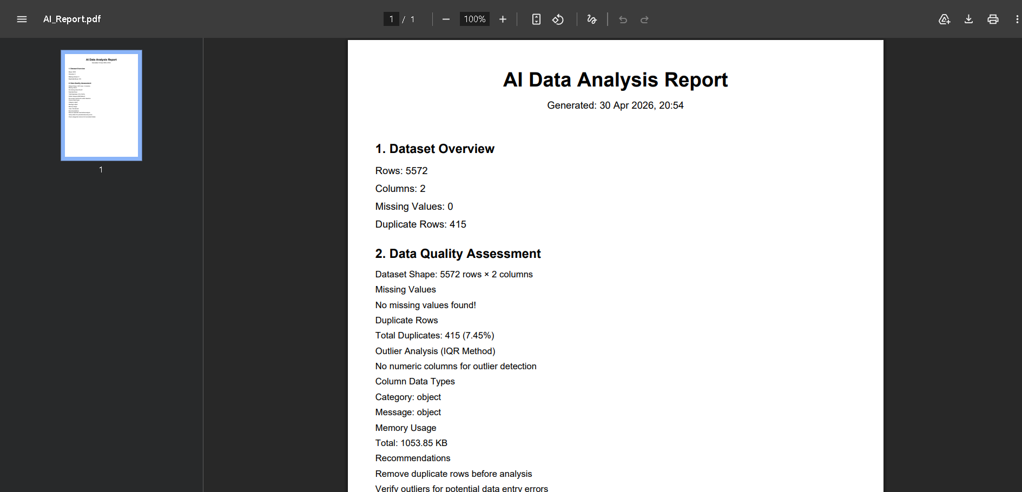
Figure 5.7: Generated PDF Report Sample with Embedded Charts and Insights

5.4 Discussion of Results
The results presented in this chapter demonstrate that the AI Data Analyst Agent effectively achieves its design objectives across multiple dimensions. This section discusses the implications of the observed results and provides analytical commentary on system strengths, limitations, and overall effectiveness.

5.4.1 Achievement of Project Objectives
The system successfully delivers on all primary objectives established in Chapter 3. Users without programming knowledge can perform comprehensive data analysis through natural

language queries, validating the core hypothesis that conversational interfaces can democratiz
e data analytics. Response times are within acceptable limits for interactive use, particularly with
the Flash Lite model that balances speed and quality effectively. The auto-generated dashboards provide immediate visual insights, dramatically reducing the time required for exploratory data analysis from hours to minutes.

The implementation of multi-format report export addresses the practical need for shareable analytical outputs, enabling users to communicate findings with stakeholders who may not have direct system access. The data quality reporting module provides crucial insights into dataset integrity, helping users make informed decisions about data preprocessing requirements before drawing analytical conclusions.

5.4.2 System Strengths
Several strengths emerge from the testing results. First, the natural language interface effectively eliminates technical barriers for non-programmer users, allowing them to access analytical capabilities previously available only through programming. Second, the comprehensive feature set covering data loading, quality assessment, statistical analysis, visualization, and reporting provides an end-to-end analytical workflow within a single platform. Third, the modular architecture facilitates maintenance and future enhancement, supporting long-term system evolution. Fourth, the use of free and open-source technologies makes the system accessible to users with limited financial resources, addressing the cost barrier identified as a key problem.

5.4.3 Observed Limitations
Despite the overall success, certain limitations were observed during testing that warrant discussion. The system experiences occasional rate limiting from the free-tier Gemini API during intensive usage, which can interrupt analytical workflows during peak activity. This limitation is inherent to the free tier and can be mitigated through paid API plans for production deployments.

Performance degradation becomes noticeable for datasets exceeding 50,000 rows due to in-memory processing constraints. While this limit is sufficient for typical analytical scenarios,

organizations with larger datasets would require alternative architectures employing database backends or distributed processing frameworks. Future enhancements could implement
intelligent sampling strategies that maintain analytical accuracy while managing memory consumption.

Dependency on internet connectivity for AI features limits offline usage, which may be problematic in environments with unreliable network access. Local LLM deployment could address this limitation in future versions, particularly important for organizations with strict data sovereignty requirements.

The analytical accuracy depends on the underlying LLM capabilities, which while impressive, are not infallible. Occasional hallucinations or misinterpretations of statistical concepts may occur, requiring users to maintain critical evaluation of AI-generated insights. This limitation is common to all current LLM-based systems and represents an ongoing research challenge in the field.

5.4.4 Comparative Discussion
When compared to existing tools reviewed in Chapter 2, the proposed system offers several distinct advantages. Unlike Excel, the system provides intelligent assistance and handles statistical analysis with appropriate sophistication. Unlike R or Python-based tools, the system requires no programming knowledge from users. Unlike Tableau or Power BI, the system is completely free and supports natural language interaction. Unlike ChatGPT Code Interpreter, the system maintains persistent context within sessions and integrates specialized analytical tools. Unlike LIDA, the system provides comprehensive analytical workflows beyond visualization.

These advantages position the proposed system as a unique offering in the analytical tools landscape, particularly suited for educational settings, small businesses, and individual researchers who require accessible yet capable analytical platforms.

5.4.5 User Experience Insights
Informal user testing with peers and faculty members provided valuable feedback on the user experience. Users particularly appreciated the immediate visual feedback through metric cards and the auto dashboard, the natural language interaction that eliminated the need to remember
specific commands or syntax, the suggested follow-up questions that guided analytical exploration, and the professional appearance of the interface that inspired confidence in the system.

Suggestions for improvement included the desire for more chart customization options, requests for the ability to save analysis sessions for later resumption, and interest in collaborative features for team-based analysis. These suggestions inform the future scope discussion in Chapter 6.

Chapter-6
CONCLUSION AND FUTURE SCOPE

This concluding chapter synthesizes the work undertaken throughout the project, presents the key findings and accomplishments, and outlines a comprehensive roadmap for future enhancements. The chapter reflects on the journey from initial concept to functional implementation, evaluates the achievement of project objectives, acknowledges learnings gained during development, and proposes specific directions for transforming this academic project into a production-ready solution suitable for commercial deployment.

The chapter is organized into two main sections. The first section presents the conclusion summarizing project accomplishments, key technical contributions, learning outcomes, and overall reflections on the project journey. The second section outlines the future scope, detailing specific enhancements, advanced features, and strategic directions that can extend the system's capabilities and impact.

6.1 Conclusion
This project successfully demonstrates the feasibility and practical utility of integrating Large Language Models with specialized analytical tools to create accessible data analysis platforms. The AI-Powered Data Analyst Agent achieves its primary objective of democratizing data

analysis by enabling users without programming expertise to derive meaningful insights through natural language interactions, addressing a critical gap in the contemporary analytical tools landscape.

6.1.1 Summary of Accomplishments
The project has delivered a fully functional, professionally designed web application that successfully combines multiple advanced technologies into a cohesive analytical platform. Key accomplishments include the successful implementation of a modular agent architecture using LangChain framework and Google Gemini API, providing the foundation for intelligent data analysis through conversational interactions. The development of a professional user interface with custom CSS styling and JavaScript enhancements creates an engaging user experience that exceeds the typical aesthetics of Streamlit applications.

The integration of comprehensive analytical tools including descriptive statistics, Pearson correlation analysis, outlier detection using the Interquartile Range method, trend analysis, and group-based aggregation provides users with a complete analytical toolkit accessible through simple natural language queries. The implementation of automated visualization generation using Plotly supports six distinct chart types with intelligent selection based on data characteristics, ensuring that generated visualizations are meaningful and appropriate for the underlying data structure.

The data quality reporting module provides crucial insights into dataset integrity through structured analysis of missing values, duplicate rows, outliers, data types, and memory usage, complete with actionable recommendations for data cleaning and preprocessing. The multi-format report export capability supporting PDF, Excel, and JSON formats addresses practical needs for sharing analytical outputs with diverse stakeholders, from technical team members who prefer JSON to executives who require polished PDF documents.

The system supports multiple Gemini model variants including Flash Lite, Flash, and Pro versions, providing users with flexibility to balance speed, quality, and API quota considerations based on their specific requirements. The conversation memory management ensures coherent
multi-turn interactions, enabling natural follow-up questions and progressive analytical exploration that mirror real-world analytical workflows.

6.1.2 Technical Contributions
Beyond the implementation of standard features, the project introduces several technical contributions worth highlighting. The simplified prompt engineering approach that passes comprehensive data context with each query proves more reliable than complex tool-calling mechanisms, providing a practical alternative for developers building LLM-based applications.

The rule-based intelligent chart selection logic embodies established data visualization best practices, ensuring meaningful automated visualizations without requiring additional API calls.
The modular architecture established through clear separation of concerns across multiple specialized files demonstrates software engineering best practices applied to AI agent development. The custom CSS implementation transforms Streamlit's default appearance into a professional interface comparable to commercial analytical platforms, demonstrating that open-source frameworks can deliver polished user experiences when combined with thoughtful design implementation.

6.1.3 Learning Outcomes
The project has provided substantial learning opportunities across multiple technical and professional domains. Technical learnings include deep practical understanding of AI agent design principles and architectures, hands-on experience with Large Language Model integration through standardized frameworks, proficiency in modern Python development including object-oriented programming and modular design, comprehensive web development skills using Streamlit framework, advanced data manipulation capabilities using Pandas and NumPy libraries, interactive visualization development using Plotly, professional report generation using FPDF2 and OpenPyXL libraries, custom user interface development using CSS3 and JavaScript, version control practices using Git and GitHub, and software documentation practices including code comments and user guides.
Professional learnings include project planning and time management across an extended development timeline, problem decomposition for tackling complex software development challenges, technical research skills through extensive literature review, technical writing skills demonstrated through comprehensive project documentation, and presentation skills developed through project demonstrations to peers and faculty.

The project has also reinforced important principles of software development including the value of iterative development with regular testing, the importance of user-centered design in creating useful software, the benefit of modular architectures for maintainability and scalability, the necessity of thorough documentation for long-term project sustainability, and the advantages of using established frameworks and libraries over custom implementations.

6.1.4 Project Impact and Significance
The completed project contributes meaningfully to the broader trend of democratizing artificial intelligence and data analytics. By demonstrating the practical viability of conversational analytics built entirely on free and open-source technologies, the project provides a template that other developers and researchers can adapt for similar challenges. The modular architecture and documented design patterns serve as reference material for educational purposes, supporting future students learning about AI agent development.

For the developer, the project represents a significant milestone in technical maturity, demonstrating the ability to conceive, design, implement, document, and present a substantial software project. The skills developed and demonstrated through this project provide a strong foundation for future endeavors including industry employment, entrepreneurial ventures, or graduate-level academic research.

6.1.5 Reflection on Challenges Overcome
The development journey involved numerous technical challenges that required creative problem-solving. Initial attempts to use LangChain's tool-calling mechanism encountered compatibility issues across different library versions, ultimately resolved by adopting the simpler context-passing approach that proved more reliable. API rate limiting from the free-tier Gemini
service required implementation of error handling and user notifications. The transition from neon-themed dark UI to professional light-themed design required substantial CSS rework but resulted in significantly improved user experience.

Each challenge contributed to learning and ultimately strengthened the final product. These experiences provide valuable lessons about the importance of flexibility in technical decision-making, the value of user feedback in driving design improvements, and the necessity of robust error handling in production-ready applications.

6.2 Future Scope
While the current implementation achieves significant functionality and demonstrates the viability of the conversational analytics approach, several enhancements are envisioned for future

development. These enhancements span multiple dimensions including technical capabilities, user features, deployment options, and commercial viability. The future scope is organized into specific enhancement areas, each representing potential paths for project evolution.

6.2.1 Local LLM Deployment
Integration of local Large Language Model solutions represents a critical enhancement for addressing data privacy concerns. Current cloud-based LLM usage requires sending dataset information to Google's servers, which may be unacceptable for organizations handling sensitive information including healthcare records, financial data, or proprietary business information. Local deployment using frameworks such as Ollama with open-source models including Llama 3, Mistral, or Phi-3 would enable on-premise operation, ensuring that sensitive data never leaves the user's infrastructure.

This enhancement would particularly benefit healthcare organizations subject to HIPAA regulations, financial institutions with strict data sovereignty requirements, government agencies handling classified information, and enterprises with intellectual property concerns. The technical implementation would require additional system requirements for local model inference but would unlock substantial new user populations currently excluded by privacy concerns.

6.2.2 Database Connectivity
Direct connectivity to relational and NoSQL databases would significantly expand the system's applicability beyond CSV file analysis. Planned database integrations include PostgreSQL for general-purpose relational data, MySQL for web application backends, Microsoft SQL Server for enterprise environments, MongoDB for document-oriented data, and Cassandra for time-series and high-volume data scenarios.

This enhancement would eliminate the CSV intermediary step currently required, enabling analysis of live operational data and supporting real-time analytical workflows. Implementation would involve developing standardized database connector modules, query builders that translate natural language requests into appropriate database queries, and security mechanisms for credential management.

6.2.3 Multi-User Collaboration
Implementation of user authentication, team workspaces, role-based access control, and shared analysis sessions would transform the system from a single-user tool to a collaborative platform suitable for team-based analytical workflows. Key features would include user registration and authentication with email verification, organization or team workspace creation supporting multiple members, role-based permissions distinguishing administrators, analysts, and viewers, shared analytical sessions where team members can collaborate on the same dataset, comment and annotation features for asynchronous collaboration, and analysis history tracking for audit purposes.

These collaborative features would position the system as a viable alternative to commercial business intelligence platforms while maintaining the natural language interaction advantages that distinguish it from traditional tools.

6.2.4 Advanced Analytics and Machine Learning
Integration of machine learning capabilities would extend the system beyond descriptive analytics into predictive and prescriptive analytics domains. Planned advanced features include predictive modeling using algorithms such as linear regression, random forests, and gradient
boosting for forecasting numeric outcomes, classification capabilities for categorizing observations into discrete classes, clustering algorithms including K-means and hierarchical clustering for identifying natural groupings, time-series forecasting using methods including ARIMA and Prophet for temporal predictions, anomaly detection algorithms for identifying unusual patterns beyond simple outlier detection, and feature importance analysis for understanding which variables drive observed outcomes.

The implementation would integrate scikit-learn for traditional machine learning, with potential additions of TensorFlow or PyTorch for deep learning capabilities. The user interface would expose these capabilities through natural language queries such as "predict next month's sales" or "identify customer segments in this data."

6.2.5 Mobile Application Development
Development of native mobile applications for iOS and Android platforms would enable on-the-go data analysis capabilities, particularly valuable for field researchers collecting data, sales professionals analyzing performance metrics, executives requiring immediate access to analytical insights, and consultants working with clients at various locations. The mobile applications would maintain feature parity with the web platform while optimizing user interface elements for touch-based interaction and smaller screen sizes.

Implementation could leverage cross-platform frameworks such as React Native or Flutter to maintain a single codebase across iOS and Android platforms, reducing development effort while ensuring consistent functionality. The mobile applications would communicate with the same backend services as the web platform, enabling seamless transitions between devices for the same user.

6.2.6 Voice Interface Integration
Integration of speech-to-text and text-to-speech capabilities would enable voice-based interaction with the analytical system, further reducing barriers to data analysis access and supporting users with accessibility requirements. Voice interaction would prove particularly valuable in scenarios
where typing is impractical, such as while driving, during meetings, or for users with motor impairments that make typing difficult.

The implementation would integrate browser-native speech APIs for web deployment and platform-specific voice services for mobile applications. The conversational interaction model already established in the system would translate naturally to voice interaction, requiring primarily user interface modifications rather than fundamental architectural changes.

6.2.7 Industry Deployment and Commercial Strategy
For commercial viability and industry deployment, the system can be transformed into a Software-as-a-Service (SaaS) offering with tiered subscription plans. The proposed pricing structure includes a Free tier providing basic features with limited usage suitable for individuals and students, a Professional tier at moderate monthly cost offering unlimited usage and advanced

features for professional analysts, and an Enterprise tier with premium pricing supporting team workspaces, local LLM deployment, white-label options, and dedicated support for organizations.

The technical transformation for commercial deployment would involve migration from Streamlit to a more scalable frontend framework such as React with Next.js for improved performance and customization, development of a robust backend API using FastAPI providing better performance and standardized REST endpoints, integration with payment processors including Stripe for international payments and Razorpay for Indian market payments, implementation of comprehensive API rate limiting to manage service usage, deployment on cloud platforms including AWS, Google Cloud, or Microsoft Azure for global accessibility, integration of monitoring and analytics tools for operational visibility, implementation of customer support systems for user assistance, and development of marketing materials including landing pages, demo videos, and documentation.

The commercialization roadmap would proceed through several phases including initial private beta testing with selected users, public beta with free tier launch to gather feedback and iterate
on features, official commercial launch with paid tiers introducing revenue generation, and progressive feature expansion based on customer feedback and market opportunities.

6.2.8 Additional Feature Enhancements
Beyond the major enhancement categories outlined above, several additional features would improve user experience and system utility. These include support for additional file formats including Excel, JSON, Parquet, and direct database imports, scheduled analysis with email reports for periodic monitoring of key metrics, custom report templates allowing organizations to brand outputs with their logos and styling, integration with collaboration tools including Slack, Microsoft Teams, and email for notifications and sharing, advanced visualization options including geographic maps, network diagrams, and interactive dashboards, natural language query history with search capabilities for revisiting previous analyses, dataset version control for tracking changes over time, integration with cloud storage services including Google Drive,

Dropbox, and OneDrive for seamless data access, and multi-language support to serve users in different geographic regions.

6.2.9 Research Directions
The project also opens several interesting research directions that could be pursued in graduate studies or research collaborations. These include comparative studies of different LLM models for analytical tasks measuring accuracy, response quality, and user satisfaction, investigation of optimal prompt engineering strategies for different analytical query types, development of specialized fine-tuned models trained specifically for data analysis tasks, exploration of multi-modal analysis incorporating images and unstructured text alongside structured data, research into automated insight quality evaluation metrics, and investigation of human-AI collaborative workflows that combine human expertise with AI capabilities.

These research directions could contribute to the broader academic literature on AI-assisted analytics while building upon the foundation established by this project.

6.3 Final Remarks
The AI-Powered Data Analyst Agent project represents a successful integration of multiple cutting-edge technologies to address a significant real-world problem. The journey from initial concept through literature review, design, implementation, testing, and documentation has provided invaluable learning experiences while delivering a functional system with practical utility.

The project demonstrates that contemporary AI technologies, when thoughtfully combined with established software engineering practices, can produce solutions that effectively democratize advanced capabilities previously accessible only to specialists. The foundation established through this work provides numerous pathways for future development, from academic research extensions to commercial product development.

As artificial intelligence continues to evolve rapidly, projects like this one serve important purposes beyond their immediate functionality. They demonstrate the practical applications of theoretical advances, provide educational resources for the next generation of developers, contribute to the open-source ecosystem that benefits the entire technology community, and inspire further innovation by showing what is possible with current technologies.

The completion of this project marks not an ending but a beginning, opening new possibilities for continued development, deeper learning, and meaningful contributions to the field of AI-assisted data analytics. The skills, knowledge, and experience gained through this work establish a strong foundation for ongoing growth and future achievements in the rapidly evolving landscape of artificial intelligence and data science.

